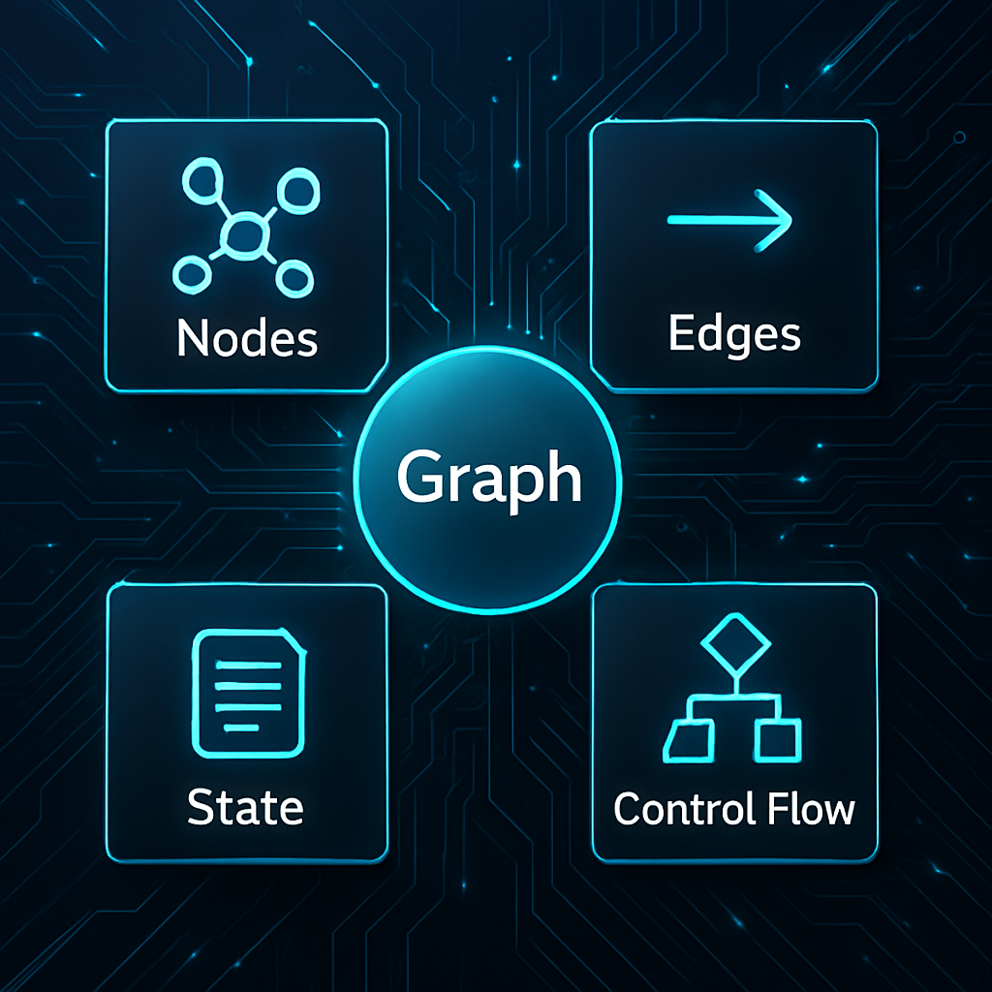

MakerAi 2.5

AGENTS Graph
CimaMaker
Correo electrónico: gustavoeenriquez@gmail.com  Sitio web: https://makerai.cimamaker.com | Doc. Versión 1.0 | 
Contenido
Módulo 1: ¿Por qué necesitamos orquestar la IA? Más allá de la simple pregunta y respuesta. 4
La Revolución Silenciosa en tu IDE 4
El Problema: El LLM es un Cerebro sin Manos 4
La Solución: Agentes y Grafos de IA 5
Módulo 2: Anatomía de un Grafo de IA con MakerAI Agents 7
La Metáfora: Un Diagrama de Flujo Inteligente 7
2.1 El Orquestador (TAIAgents): El Cerebro del Operativo 7
2.2 El Nodo (TAIAgentsNode): La Unidad de Trabajo 8
Propiedades y Conceptos Clave: 8
El Papel del Nodo en el Grafo: 10
2.3 El Enlace (TAIAgentsLink): Definiendo el Flujo y la Lógica 10
Capacidades Clave de un Enlace: 10
2.4 La Pizarra (TAIBlackboard): La Memoria Compartida del Grafo 12
¿Qué es y cómo funciona? 12
Métodos Principales: 12
2.5 La Herramienta (TAiToolBase): Dando Capacidades al Agente 14
¿Por qué usar Herramientas? 14
Anatomía de una Herramienta: 14
¿Cómo se usa? 15
Módulo 3: ¡Hola, Mundo! - Tu Primer Grafo 16
Módulo 4: Tomando Decisiones - Enrutamiento Condicional 20
Paso 1: Diseño del Grafo en el Formulario 20
Paso 2: Implementando la Lógica de Decisión 21
Paso 3: Configurando el Enlace Condicional por Código 22
Paso 4: ¡A Probarlo! 23
Módulo 5: Dividir y Conquistar - Ejecución en Paralelo (Fan-out) 25
Paso 1: Diseño del Grafo Paralelo 25
Paso 2: Implementando la Lógica Paralela 27
Paso 3: ¡A Probarlo! 27
Módulo 6: Juntando las Piezas - Sincronización de Ramas (Join) 29
Paso 1: Rediseñando el Grafo para la Unión 29
Paso 2: Implementando la Lógica de Unión 31
Paso 3: ¡A Probarlo! 31
Módulo 7: Creando Agentes Autónomos con Herramientas 33
Paso 1: Creando Nuestra Primera Herramienta (TWeatherTool) 33
Paso 2: Construyendo el Grafo que Usará la Herramienta 34
Módulo 8: Gestión de Errores y Ciclos 37
Paso 1: Diseño del Grafo Robusto 37
Paso 2: Implementando la Lógica de Fallo y Reintento 38
Paso 3: Manejando Excepciones Fatales (OnError) 39
Paso 4: ¡A Probarlo! 40
Apéndice A: Referencia de la API 41
A.1 TAIAgents (El Orquestador) 41
A.2 TAIAgentsNode (El Nodo) 42
A.3 TAIAgentsLink (El Enlace) 42
A.4 TAIBlackboard (La Pizarra) 43
Apéndice B: Creación de Herramientas Personalizadas (TAiToolBase) 44
B.1 La Estructura Fundamental de una Herramienta 44
B.2 Interactuando con el Grafo desde una Herramienta 45
B.3 Registrando tus Herramientas como Componentes 46
Apéndice C: Construcción de Grafos Dinámicamente (Fluent API) 47
C.1 Los Bloques de Construcción de la API Fluida 47
C.2 Ejemplo Práctico: Recreando el Grafo Condicional por Código 48
Glosario de Términos 50

Module 1: Why do we need to orchestrate AI? Beyond the simple question and answer.

The Silent Revolution in your IDE
As a Delphi developer, you are used to building robust, fast and reliable applications. For decades, we have mastered creating complex systems, fromERPsand points of sale to industrial software. Today, a new revolution is knocking on our door: Generative Artificial Intelligence and Large Language Models (LLMs) such as GPT, Gemini or Llama.
Integrating an LLM API call into a Delphi application is relatively simple. With components likeTRESTClient, we can send a question and receive a response. This is helpful, but it's just the tip of the iceberg. We soon encounter more complex questions:
- "How can I have the LLM query my customer database to answer a question?"
- "What if I need, after generating a report, to automatically send it by email?"
- "How can I maintain a coherent conversation with a user, remembering what was said before?"
- "What if a task requires multiple steps of reasoning and access to different tools?"
This is where a simple API call falls short.

The Problem: The LLM is a Brain Without Hands
Imagine an LLM as an incredibly intelligent and articulate brain, but it is isolated in a room with no doors or windows. You can reason, write, and generate ideas, but you cannot interact with the outside world. It can't search the internet, it can't read a file on your hard drive, it can't query your SQL database, nor can it execute an action in your application.
When we try to solve real-world problems that require more than just generating text, we face these limitations:
- Lack of Updated Context:LLMs are trained with data that has a cut-off date. They don't know what happened yesterday, or what the current stock of your best-selling product is.
- Inability to Act:They cannot execute actions. They cannot click a button, call an external API (on their own), or modify a record in a database.
- Multi-Step Complexity:Tasks like “Research the latest market trends for product
Trying to manage this logic manually in your Delphi code can quickly become a "spaghetti" ofif-then-else, nested calls to APIs and fragile and difficult to maintain state management.

The Solution: AI Agents and Graphs
The solution is not to ask the LLM to do everything, but to treat it as another (albeit very special) component within a larger workflow. This is where theorchestration.
MakerAI Agentsallows you to build these intelligent workflows in a structured, visual and powerful way. The central idea is simple:decomposing a complex problem into a series of interconnected steps, forming what we call an "AI Graph".
To understand how it works, let's introduce some key concepts:
- Agente (Agent):An agent is not just an LLM. It is a system that uses an LLM as its "reasoning engine" to make decisions and act. The agent looks at an input (for example, a user question), thinks about what steps it should take to resolve it, and uses the tools at its disposal to execute those steps.
- Herramienta (Tool):A tool is the “hand” we give to our AI brain. It is a well-defined Delphi function or procedure that the agent can execute to interact with the outside world.
  - TDatabaseTool: A tool for executing SQL queries.
  - TFileTool: A tool for reading or writing files.
  - TWebApiTool: A tool to consume data from an external API (e.g. weather, stock prices, etc.).
- Cadenas (Chains) vs. Grafos (Graphs):
  - oneCadenais the simplest form of orchestration: a linear flow where the output of step A becomes the input of step B, that of B becomes that of C, and so on.Example: Translate a text -> Summarize the translated text -> Analyze the sentiment of the summary.
  - AGrafoIt is a much more powerful and flexible structure, necessary for most real-world problems. Allows:
    - Ramas (Branches):Take different paths based on a condition (e.g. if the feeling is positive, do X; if it is negative, do Y).
    - Parallelization (Fan-out):Execute multiple steps at the same time to improve efficiency.
    - Uniones (Joins):Wait for several parallel branches to finish before continuing.
    - Ciclos (Cycles):Repeat a set of steps until a condition is met (e.g. the agent tries to use a tool, if it fails, it reasons again and tries another way).
- Estado (State) and the Blackboard:For the different steps of a graph to communicate with each other, they need a shared place where they can read and write information. This is the role ofPizarra (TAIBlackboard). It is a persistent memory for a single execution of the graph. A node can write a result on the whiteboard (e.g.Blackboard.SetString('CustomerID', '123')), and another node, later in the flow, can read that value to perform its task.

Module 2: Anatomy of an AI Graph with MakerAI Agents

The Metaphor: A Smart Flowchart
If you've ever designed a flowchart to represent a business process or algorithm, you're already halfway to understanding how it works.MakerAI Agents.
Imagine each box in your diagram as a unit of work (TAIAgentsNode) and each arrow connecting them as a flow path (TAIAgentsLink). Now, imagine that inside some of those boxes is an AI "brain" capable of making decisions, and that the arrows can change direction dynamically based on the results. That is, in essence, an AI Graph.
MakerAI Agentsallows you to build these smart flowcharts directly in the Delphi forms designer or create them dynamically by code. Each piece ofpuzzleis a Delphi component, with properties that you can configure in the Object Inspector and events that you can implement in the Code Editor.
Let's break down the fundamental pieces that make up any graph you build.

2.1 The Orchestrator (TAIAgents): The Operative Brain
The componentTAIAgentsIt is the heart and brain of the entire system. It does not perform any business tasks itself, but is responsible for managing and executing the entire network. Think of it like the conductor of an orchestra: he doesn't play any instruments, but he makes sure that all the musicians (the nodes) come in on time, follow the score (the flow), and work in harmony.
You will place a componentTAIAgentson your form orDataModuleas the main entry point for your AI logic.
Responsabilidades Clave:
- Graph Container:It is the "owner" of all nodes (TAIAgentsNode) and links (TAIAgentsLink) that are part of the graph. When you place a node on the form, it is automatically associated with the main orchestrator.
- Entry and Exit Point:Through its propertiesStartNodeandEndNode, you tell the orchestrator where the execution flow should start and where it should end.
  - StartNode: The first node that will run when you call the Run method.
  - EndNode: A special node that marks the successful completion of the graph.
- Execution Engine:The methodRun(Input: string): ITaskHe is the one that sets everything in motion. Starts the execution of the graph in a secondary thread (TTask) to not block your app's UI, and returns a task (ITask) which you can use to wait for it to finish if necessary.
- Centralized State Management:The orchestrator has thePizarra (Blackboard), which is the shared state for the entire execution of the graph. We will look at the board in detail later, but it is crucial to understand what theTAIAgentswho manages it.
- Global Event Management:Provides graph-level events to centrally manage communication and errors.
  - OnPrint: A useful event for theloggingand debugging. Any node or link in the graph can call its methodPrint, and this event will fire.
  - OnError: A global try-catch for your graph. If any node or link throws an exception during execution, this event is captured, allowing you to log the error, notify the user, or decide whether to abort the execution.
  - OnEnd: Triggered when the graph finishes its execution (either reaching theEndNodeor being aborted). This is where you will normally collect the final result of the Output from the last node or from the Blackboard.
  - OnConfirm: Facilitates interaction with the user. Allows a node to stop the flow and ask a question to the user (via the main UI), waiting for a response before continuing.
In Practice:
On your form, you will have a singleTAIAgents. You'll configure it by assigning the start and end nodes, and probably implement the eventsOnEndandOnErrorto know when the job is finished and if something has gone wrong. All the complex and specific logic for each step will reside in the individual nodes, keeping your code clean and organized.

2.2 The Node (TAIAgentsNode): The Work Unit
If heTAIAgentsHe is the director of the orchestra,TAIAgentsNodeis the musician. Each node representsa discreet and specific stepwithin your workflow. It is a box in our "smart flowchart" that receives an input, performs an action, and produces an output.
The beauty of this approach is that you can create nodes for any type of task, from a simple text manipulation to a complex AI model call, a database query, or the execution of a specialized tool.

Key Properties and Concepts:
- Input and OutputString):
  - Input: The data that the node receives to work with. By default, the Input of a node is automatically filled with the Output of the node that preceded it in the flow.
  - Output: The result of the work performed by the node. This value will be passed as Input to the next connected node. If left unchanged, Output is equal to Input, allowing data to flow through nodes that do not need to alter it.
- OnExecute (Evento):This is the logical heart of the node. It is a type eventprocedure(Node, BeforeNode: TAIAgentsNode; Link: TAIAgentsLink; Input: String; var Output: String) where you write the code that defines what this node does.
  - You receive the Input.
  - You perform your logic (call a function, an API, process the text...).
  - You assign the result to the parametervar Output.
- Next (TAIAgentsLink):This property connects the node to the next step in the flow. From a node, you can only exita link. However, as we will see in the next section, that single link can have multiple destinations, allowing parallel execution.
- Tool (TAiToolBase):A powerful alternative to the eventOnExecute. Instead of writing the code directly in the form's event, you can associate a predefined "Tool" (a componentTAiToolBase). When the node runs, if it has a Tool assigned, it will call the methodExecuteof that tool. This promotes thecode reuseand theseparation of responsibilities. For example, you can have a singleTDatabaseQueryTooland use it on multiple nodes along different graphs. The node that has the highest priority is theOnExecuteover the Tool.
- JoinModeand Synchronization:
A node can be the arrival point of multiple links (for example, after parallel execution). The propertyJoinModecontrols how the node behaves in this situation:
  - jmAny(Default): The node will runevery timethat one of the input branches reaches it. This is ideal for graphs that contain cycles or loops.
  - jmAll: The nodewill waitto whattodasthe input branches have completed their execution and reached it before executing a single time. This is essential to synchronize parallel tasks before proceeding to the next step (such as consolidating the results into a final report).

The Role of the Node in the Graph:
You can have different types of nodes depending on their function:
- Processing Nodes:They perform a specific task, such as calling an LLM, formatting text, performing a calculation, etc.
- Routing Nodes:Nodes whose main function is to analyze the current state (often reading from the Blackboard) to make a decision that will influence the path the flow will take.
- Tool Nodes:Nodes that act as executors of actions in the real world, using the Tool component.
- Wait/Join Nodes:Nodes configured withJoinMode = jmAllthat serve as synchronization points in the graph.
When designing your graph, think of each task as a separate node. This makes your workflow modular, easier to understand, debug and maintain.

2.3 The Link (TAIAgentsLink): Defining Flow and Logic
If the nodes are the cities on our map, the links (TAIAgentsLink) are the roads that connect them. A link defines the path that data and control follow from one node to another. However, inMakerAI Agents, a link is much more than a simple arrow; can contain its own logic to create dynamic and complex workflows.
EachTAIAgentsNodehas a single output property, Next, where aTAIAgentsLink. It is this link that determines what happens next.

Key Capabilities of a Link:
- Simple Connection (Single Destination):
In its most basic form, a link connects one node to another. This is done by assigning the destination node to the propertyNextAof the link. This is the building block for building linear chains (A -> B -> C).
- Parallel Execution (Fan-out):
This is where the power begins to manifest. A single link can have multiple destinations. The propertiesNextA, NextB, NextC, andNextDThey can each point to a different node. When the flow reaches this link,all target nodes run simultaneously, each in their own thread. This is ideal for tasks that do not depend on each other and can be done at the same time to save time.
  - Ejemplo:A node receives a product request. Its outbound link is split so that three nodes run in parallel: one checks stock, another searches for customer reviews, and a third searches for competing products.
- Failure Routes (Fallback):
The propertyNextNodefines an alternative route. It is used in conjunction with the link's own conditional logic to handle cases of "failure" or when a condition is not met.
  - MaxCicles: This property sets a maximum number of times this link can be passed in a loop before considering it a failure and taking the routeNextNo. This is a crucial safety mechanism to avoid infinite loops.
- Conditional Routing (Smart Decision):
This is one of the most advanced and powerful features, which elevates your graph from a simple script to a reasoning system. A link can function as a "switch" or a "router".
  - How it works:Instead of usingNextA, NextB, etc., a dictionary of conditional destinations is defined. The link, when executed, will query a specific key in Blackboard (by ejemplo, Blackboard.GetString('next_route')). The value of that key will determine which of the destination nodes the flow will be routed to.
  - Ejemplo:A node (ClassifierNode) analyzes an email and writes on Blackboard whether it is "SALES", "SUPPORT" or "SPAM". The outbound link of this node is configured with three conditional routes. Yes 'next_route' is "SALES", the flow goes toSalesTeamNode; if it is "SUPPORT", it goes toSupportTeamNode, and so on.
- Custom Logic in Transition (OnExecute):
Like a node, a link also has an eventOnExecute. This event gives you precise control over the transition.
procedure(Node: TAIAgentsNode; Link: TAIAgentsLink; var IsOk: Boolean; var Handled: Boolean)
  - You can perform validations before moving to the next node.
  - Modificando IsOk :=False, you can force the transition to be considered a "failure", which may redirect the flow toNextNoif it is configured.
  - Estableciendo Handled := True, you can completely stop the flow at this point, without the link continuing to any of its destinations.

In essence, theTAIAgentsLinkallows you to decide not onlywhere tothe flow goes, but alsohowandwhygoes there. The combination of parallelism, failure paths, and conditional routing is what allows you to build graphs that can adapt, react, and make complex decisions.

2.4 The Blackboard (TAIBlackboard): The Shared Memory of the Graph
If the nodes are the offices of a company and the links are the hallways, the whiteboard (TAIBlackboard) is the central bulletin board where everyone can read important messages and leave notes for others.
In a graph, nodes often run independently and, in cases of parallelism, even in different threads. Blackboard is the mechanism that allows them to communicate and share information in a secure and centralized way. It is, in effect, thememoria a corto plazoof a single execution of the network.
Blackboard is a property of the orchestratorTAIAgents, meaning that there is only one instance per graph and it is accessible from any node, link, or tool within that graph.

What is it and how does it work?
Technically, theTAIBlackboardis a thread-safe dictionary (thread-safe) that stores key-value pairs. The key is always astring, and the value can be of various types (TValue), incluyendo:
- String
- Integer
- Boolean
- Double
- And other types supported byTValue.

Main Methods:
For ease of use, Blackboard offers direct and typed methods:
- SetString(const AKey, AValue: string): Writes or updates a text type value.
- GetString(const AKey: string; const ADefault: string = ''): string: Read a text value. If the key does not exist, it returns the default value.
- SetInteger(...), GetInteger(...)
- SetBoolean(...), GetBoolean(...)
And generic methods to work withTValue:
- SetValue(const AKey: string; const AValue: TValue)
- TryGetValue(const AKey: string; out AValue: TValue): Boolean
Crucial Use Cases:
- Passing Complex Information between Nodes:
While a node's Input/Output is ideal for passing the main result from one step to the next, you often need to pass multiple pieces of information.
  - Ejemplo:AGetUserNodeGets the ID, name, and subscription level of a user. Instead of concatenating everything into onestringoutput, you can write each data on the Blackboard:
Graph.Blackboard.SetInteger('UserID', 123);
Graph.Blackboard.SetString('UserName', 'John Doe');
Graph.Blackboard.SetString('Subscription', 'Premium');

Subsequent nodes can now read this information directly, without needing toparsearastring complejo.

- Enable Conditional Routing:
This is the most important use case. As we saw in the links section, conditional routing depends on a node writing a “decision” to the Blackboard.
  - Ejemplo:
// Inside theOnExecuteof a classification node
var Classification: string;
Classification := MyLLM.Classify(Input); // Devuelve 'support' or 'salts'
Graph.Blackboard.SetString('next_route', Classification);

The next link in the graph will read the value of 'next_route' to decide which node to direct the flow to.

- Add Parallel Branch Results:
When you have multiple nodes running in parallel, each one can do its job and write its result to the Blackboard using a unique key. The union node (JoinNode) that comes next can then read all the results from the board to consolidate them.
  - Ejemplo:
// InSummarizeNode
Graph.Blackboard.SetString('summary_result', SummaryText);
// InKeywordsNode
Graph.Blackboard.SetString('keywords_result', KeywordsList);
// InReportNode(the union node)
var FinalReport: TStringBuilder;
FinalReport.AppendLine(Graph.Blackboard.GetString('summary_result'));
FinalReport.AppendLine(Graph.Blackboard.GetString('keywords_result'));

- Maintain Counters or State Flags:
You can use Blackboard to track the status of the execution, such as the number of retries, whether a critical action has already been performed, etc.

The Blackboard is automatically cleaned at the start of each Run, ensuring that each graph operation starts with a clean state. It is the tool that transforms a collection of isolated steps into a coherent, stateful process.

2.5 The Tool (TAiToolBase): Dando Capacidades al Agente
So far, we have seen how to build internal workflows. But the true power of an AI agent lies in its ability tointeract with external systems- Query a database, read a file, call a web API, or perform any other action in your application.
This is where theHerramienta (TAiToolBase).
A tool is a reusable Delphi component that encapsulates a specific capability. Instead of writing data or API access logic directly in the eventOnExecuteof a node, you encapsulate it within a class that inherits fromTAiToolBase.

Why use Tools?
- Reuse:You can create a tool once (for example,TExecuteSQLQueryTool) and use it on countless nodes across many different graphs. If you need to update the way you connect to the database, you do it in one place: the tool class.
- Separation of Responsibilities (SoC):Keeps your graph "clean". The graph is responsible for theorchestration(the "what" and the "when"), while the tools are responsible for theexecution(the "how"). This makes your logic much easier to read, test, and maintain.
- Abstraction:A node does not need to know the details of how a tool works. You simply know that you have a tool that, for example, "gets the price of a product." The complexity of the API call, error handling, andparseoof the answer is hidden within the tool.
- Preparation for Self-Employed Agents:This is the most important point for the future. Advanced agent systems (such as those usingFunction CallingorReAct) work by presenting an LLM with a list of available tools. The LLM, based on the user's question, decides which tool to use and with what parameters. By structuring your capabilities asTAiToolBase, you are already building the system in the right way to be able, in the future, to allow the LLM to make these decisions autonomously.

Anatomy of a Tool:
Creating a tool is very simple. You must create a new class that inherits fromTAiToolBaseandsobreescribira single method:

type
TMyCustomTool = class(TAiToolBase)
protected
procedure Execute(ANode: TAIAgentsNode; const AInput: string; var AOutput: string); override;
published
property Description; // Inherited and very important
end;

procedure TMyCustomTool.Execute(ANode: TAIAgentsNode; const AInput: string; var AOutput: string);
begin
// Aqui­ va tu lorgica.
// AInput: Contains the entry of the node thatestÃ¡ usando.
// ANode: Gives you access to the node youestÃ¡ ejecutando, in case you need
// llamar a Print() or access Blackboard (ANode.Graph.Blackboard).

// Ejemplo:
ANode.Print(Format('Mi herramienta se estÃ¡ executing with the input: %s', [AInput]));
AOutput := 'Result of my tool processing' + AInput;
end;

- Execute(Method):It is the heart of the tool. Here you implement what the tool should do.
- Description (Propiedad):It is essential to document what the tool does here. This description is not just for other developers; is the text that an LLM would use to understand the capability of the tool and decide whether to use it. A good description would be: "Look up the current price of a product in the inventory database. The entry should be the SKU of the product."

How to use it?
- You create an instance of your tool (you can do this in the forms designer if you register it as a component, or by code).
- In theTAIAgentsNodethat you want me to use this tool, instead of implementing theOnExecute, you assign your tool instance to the node's Tool property.

When the graph executes that node, it will automatically call the methodExecuteof the assigned tool, passing it the node's Input and waiting for the tool to fill the Output.
With this last pillar, you now have a complete vision of all the pieces that make upMakerAI Agents. You've learned about the orchestrator, the nodes that do the work, the links that define the flow, the whiteboard that shares state, and the tools that connect your graph to the real world.

Module 3: Hello, World! - Your First Graph
In this module, we'll put theory aside to build our first functional AI graph. The goal is simple, but it will allow us to become familiar with the basic workflow ofMakerAI Agents: place components, connect them and run the graph.
Objetivo:
We'll create a simple graph that takes a name as input (for example, "World") and produces a custom greeting as output ("Hello, World").
Components that we will use:
- 1 x TAIAgents: The main orchestrator.
- 2 x TAIAgentsNode: One for the start (StartNode) and another for the end (EndNode).
- 1 x TAIAgentsLink: To connect our two nodes.
- Standard VCL/FMX components:TEditfor the entrance,TButtonto execute andTMemoto view the logsOnPrint.

Step 1: Setting the Stage in the Form
- Open a new VCL or FMX project in Delphi.
- From the Components Palette, in the "MakerAI" tab, drag and drop the following components onto your form:
  - TAIAgents
  - TAIAgentsNode
  - TAIAgentsNode
  - TAIAgentsLink
- Add the UI components:TEdit, TButtonandTMemo.
- Rename components for clarity.This is a good practice that will help you enormously in more complex graphs. Select each component and, in the Object Inspector, change its propertyName:
TAIAgents1 -> AgentManager
TAIAgentsNode1 -> nodeStart
TAIAgentsNode2 -> nodeEnd
TAIAgentsLink1 -> linkStartToEnd
TMemo1 -> memoLog
TEdit1 -> editInput (y limpia su propiedad Text)
TButton1 -> btnRun (y cambia su Caption/Text a "Ejecutar")

Your form should look something like this (non-visual components will appear at the bottom or as icons):

Step 2: Configuring the Graph
Now we are going to "wire" our components to define the structure of the graph. All this is done through the Object Inspector.
- Configure the Orchestrator (AgentManager):
  - Select the componentAgentManager.
  - Search the propertyStartNode. Click on the dropdown and select nodeStart.
  - Search the propertyEndNode. Click on the dropdown and selecciona nodeEnd.
- Connect the Nodes with the Link:
  - Selecciona nodeStart.
  - Find your property Next. In the dropdown, selectlinkStartToEnd. This tells the initial node that when it is finished, it should pass control to the link.
  - Selecciona linkStartToEnd.
  - Busca su propiedad NextA. In the dropdown, selectnodeEnd. This tells the link that its only destination is the end node.
That's all! You have just visually defined a flownodeStart -> linkStartToEnd -> nodeEnd.

Step 3: Implementing the Logic
Ahora necesitamos decirle a nuestro nodeStartwhat to do This is where we will write our first piece of AI code.
- Implement the logic of thenodeStart:
  - Selecciona nodeStarton the form.
  - Go to the Object Inspector, to theEventos.
  - Double click on the eventOnExecute. The IDE will generate the skeleton of the procedure.
  - Write the following code:

procedure TForm1.nodeStartExecute(Node, BeforeNode: TAIAgentsNode;
Link: TAIAgentsLink; Input: String; var Output: String);
begin
// 1. We print a log message to see that we are here.
// Cualquier llamada a Print() on a node is redirected to the eventOnPrintof the orchestrator.
Node.Print(Format('Nodo Start: Recibido input "%s"', [Input]));

// 2. The main logic: create the greeting.
// The 'Input' parameter contains what was passed to the methodRun().
Output := 'Hola, ' + Input;

// 3. We print the result that we are going to pass to the next node.
Node.Print(Format('Nodo Start: Generado output "%s"', [Output]));
end;

- Connect Orchestrator Events:
Necesitamos decirle al AgentManagerwhat to do with messagesPrintand what to do when the graph ends.
  - Selecciona AgentManager.
  - In the tabEventos, double clickOnPrint. Write this code to display the logs in ourTMemo:

procedure TForm1.AgentManagerPrint(Sender: TObject; Value: String);
begin
// We show the message in theTMemo, making sure it is thread safe.
TThread.Synchronize(nil,
procedure
begin
memoLog.Lines.Add(Format('[%s] %s', [TObject(Sender).ClassName], Value));
end);
end;

  - Now, double click on the eventOnEnd. This is where we will receive the final result of the entire process.

procedure TForm1.AgentManagerEnd(Node: TAIAgentsNode; Value: string);
begin
// 'Node' is the last node that ran (in our case,nodeEnd).
// 'Value' is the final Output of that last node.
TThread.Synchronize(nil,
procedure
begin
ShowMessage('El grafo ha finalizado. Resultado final: ' + Value);
btnRun.Enabled :=True; // We reactivate the button
end);
end;

  - Importante:Note the use ofTThread.Synchronize. Agent events are executed in a secondary thread. Any interaction with the user interface (UI)mustbe done withinTThread.Synchronizeto avoid concurrent access errors.

Paso 4: ¡Ejecutar!
The only thing left is to call the agent's Run method from our button.
- Double click on thebtnRunin the forms designer.
- Write the following code in the eventOnClick:

procedure TForm1.btnRunClick(Sender: TObject);
begin
memoLog.Clear;
btnRun.Enabled :=False; // We disable the button while it is running.
AgentManager.Run(editInput.Text);
end;

¡A Probarlo!
Run your application (F9).
- Write "World" on theTEdit.
- Click the "Run" button.
What you will see:
- The button will be disabled.
- In theTMemo, the logs will appear almost instantly:

[TAIAgentsNode] Nodo Start: Recibido input "Mundo"
[TAIAgentsNode] Nodo Start: Generado output "Hola, Mundo"

- A will appearShowMessagewith the text: "The graph has ended. Final result: Hello, World."
- The "Run" button will be activated again.
¡Felicidades!You have just built and run your first AI Graph. You have learned to:
- Configure the orchestrator and define the graph flow.
- Implement the logic of a node.
- Handle log and completion events.
- Run the graph asynchronously.
Although this example is simple, the principles you've applied are the basis for building incredibly complex agents and workflows.

Module 4: Making Decisions - Conditional Routing
In the real world, processes are rarely linear. Often, we need to take one path or another based on certain information. In this module, we will build a graph that simulates the sentiment analysis of a text. If the text is considered "positive", it will follow a path; if it is "negative", another will follow.
Objetivo:
Create a graph that receives a text. A central node will "analyze" whether the text contains the word "good" (simulating a positive analysis) or "bad" (simulating a negative one). Depending on the result, the flow will be directed to a positive response node or a negative response node.
Components that we will use:
- 1 x TAIAgents(we can reuse the one from the previous module)
- 4 x TAIAgentsNode
- 3 x TAIAgentsLink

Step 1: Design of the Graph in the Form
We are going to modify the form of the previous module or create a new one.
- Place and rename components:
AgentManager (TAIAgents)
nodeStart (TAIAgentsNode)
nodeAnalyze (TAIAgentsNode): This will be our decision node.
nodePositiveResponse (TAIAgentsNode): Will be executed if the sentiment is positive.
nodeNegativeResponse (TAIAgentsNode): Will be executed if the sentiment is negative.
nodeEnd (TAIAgentsNode): Will be the common endpoint.

- Configure the Orchestrator (AgentManager):
  - StartNode: nodeStart
  - EndNode: nodeEnd
- Graph Wiring (the crucial part):
This graph has a branch, so pay attention to the connections.
  - OfnodeStart a nodeAnalyze:
    - Create a linklinkStartToAnalyze.
    - nodeStart.Next -> linkStartToAnalyze
    - linkStartToAnalyze.NextA -> nodeAnalyze
  - The branch fromnodeAnalyze:
    - This is the most important step.nodeAnalyzewill have a single outbound link, but this link will becondicional.
    - Create a link and call itlinkConditionalRouter.
    - nodeAnalyze.Next -> linkConditionalRouter
    - ¡No configures NextAinlinkConditionalRouter!We will do it by code to define the conditional routes.
  - From the branches tonodeEnd:
    - Create a linklinkPositiveToEnd.
    - nodePositiveResponse.Next -> linkPositiveToEnd
    - linkPositiveToEnd.NextA -> nodeEnd
    - Create a linklinkNegativeToEnd.
    - nodeNegativeResponse.Next -> linkNegativeToEnd
    - linkNegativeToEnd.NextA -> nodeEnd
Visually, your flow will look like this:

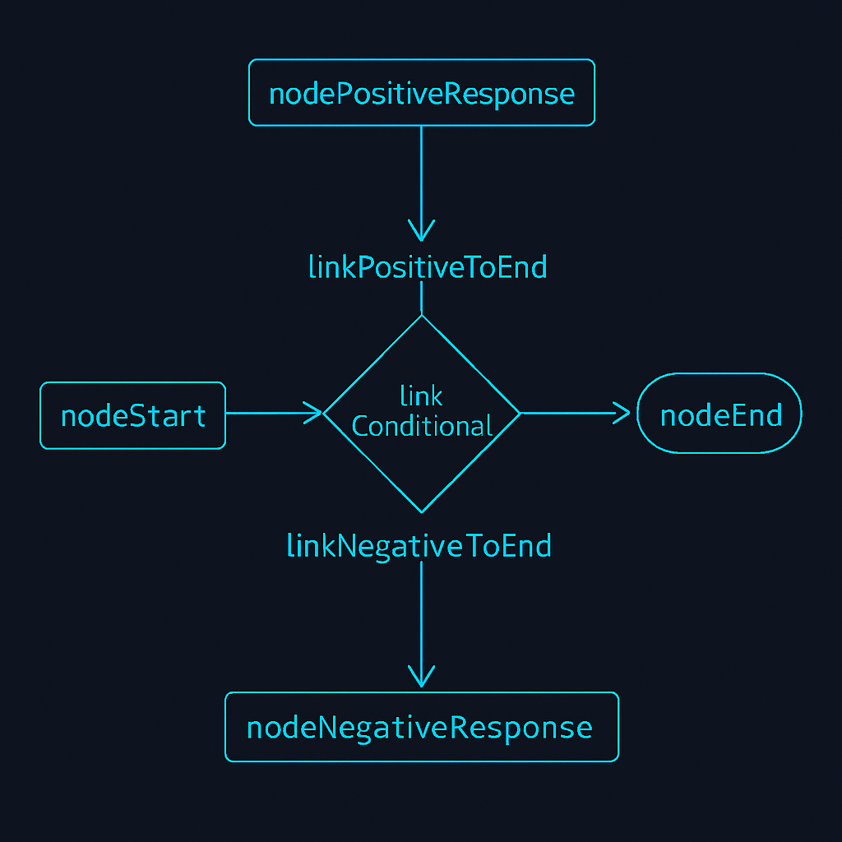

Step 2: Implementing the Decision Logic
The magic of conditional routing lies in two parts:
- A node writes a “decision” on the Blackboard.
- A subsequent link reads that decision and routes the flow based on it.
- Logic ofnodeStart:
This node will simply pass the input. Double click on your eventOnExecute.
procedure TForm1.nodeStartExecute(Node, BeforeNode: TAIAgentsNode;
Link: TAIAgentsLink; Input: String; var Output: String);
begin
Node.Print('Step 1: Starting analysis with text: ' + Input);
// We simply pass the input to the next node
Output := Input;
end;

- Logic ofnodeAnalyze (El Cerebro):
This is the node that makes the decision.

procedure TForm1.nodeAnalyzeExecute(Node, BeforeNode: TAIAgentsNode;
Link: TAIAgentsLink; Input: String; var Output: String);
var
Decision: string;
begin
// We simulate a sentiment analysis
if Pos('bien', Input.ToLower) > 0 then
Decision := 'positivo'
else if Pos('mal', Input.ToLower) > 0 then
Decision := 'negativo'
else
Decision := 'neutral'; // A default route

Node.Print('Step 2: Analysis completed. Decision: ' +Decision);

// Here's the key! We write the decision on Blackboard.
// The conditional link will use this key to route.
Node.Graph.Blackboard.SetString('next_route', Decision);

// We pass the decision as output for subsequent nodes to use.
Output := 'El sentimiento detectado fue: ' + Decision;
end;

  - Node.Graph.Blackboard: This is how we access Blackboard from a node.
  - 'next_route': This is the key name that the system uses by default for conditional routing.
- Response Node Logic:
These nodes simply generate a final message based on the route taken.
procedure TForm1.nodePositiveResponseExecute(Node, BeforeNode: TAIAgentsNode;
Link: TAIAgentsLink; Input: String; var Output: String);
begin
Node.Print('Ruta Positiva: Generando respuesta optimista.');
Output := 'Thank you for your positive comments!';
end;

procedure TForm1.nodeNegativeResponseExecute(Node, BeforeNode: TAIAgentsNode;
Link: TAIAgentsLink; Input: String; var Output: String);
begin
Node.Print('Negative Path: Generating apology response.');
Output := 'We are sorry that your experience was not good.';
end;

Step 3: Configuring Conditional Link by Code
The Delphi designer is great for simple connections, but conditional routes are more easily defined by code, usually in the eventOnCreateof the form.
- Ve al evento OnCreateof your form.
- Add the following code to "teach" thelinkConditionalRouter sus posibles destinos:

procedure TForm1.FormCreate(Sender: TObject);
begin
// Add the routes to the conditional link
linkConditionalRouter.AddConditionalTarget('positivo', nodePositiveResponse);
linkConditionalRouter.AddConditionalTarget('negativo', nodeNegativeResponse);

// Optional: What if the decision is neither 'positive' nor 'negative'?
// We can define a default destination. In this case, if it is 'neutral' or
// anything else will go straight to the end.
linkConditionalRouter.NextNo := nodeEnd;
end;

  - AddConditionalTarget(Key, Node): This method tells the link: 'When the key 'next_route' from Blackboard contains the Key value, directs the flow toNode especificado".
  - NextNo: If the value in the Blackboard does not match any of the conditional keys, the flow will take this alternative path. If we do not define it and there is no match, the graph will stop with an error.

Paso 4: ¡A Probarlo!
Use the same UI as the previous module (TEdit, TButton, TMemo) and the same code for the eventsOnPrint, OnEndandOnClickof the button.
Prueba 1: Sentimiento Positivo
- Write in theTEdit: "The service was very good."
- Click "Run."
- Log esperado:

[TAIAgentsNode] Step 1: Starting analysis...
[TAIAgentsNode] Step 2: Analysis completed. Decision: positive
[TAIAgentsNode] Ruta Positiva: Generando respuesta optimista.

- Mensaje final:"The network has ended. Final result: Thank you for your positive comments!"
Prueba 2: Sentimiento Negativo
- Write in theTEdit: "What a bad time I had."
- Click "Run."
- Log esperado:

[TAIAgentsNode] Step 1: Starting analysis...
[TAIAgentsNode] Step 2: Analysis completed. Decision: negative
[TAIAgentsNode] Negative Route: Generating an apology response.

- Mensaje final:"The network has ended. Final result: We are sorry that your experience was not good."
Prueba 3: Sentimiento Neutro
- Write in theTEdit: "The day is cloudy."
- Click "Run."
- Log esperado:

[TAIAgentsNode] Step 1: Starting analysis...
[TAIAgentsNode] Step 2: Analysis completed. Decision: neutral

- Mensaje final:"The network has ended. Final result: The sentiment detected was: neutral." (The flow was direct to thenodeEndthrough the routeNextNo).
You have just built a graph that reacts dynamically to its input data. This pattern is the basis for creating agents that can choose which tool to use, decide if they need more information from the user, or handle different types of requests intelligently.

Module 5: Divide and Conquer - Parallel Execution (Fan-out)
Often a problem requires performing several independent tasks that do not depend on each other. For example, to create a complete report on a topic, we might want to generate a summary, extract the keywords, and translate it into another language. Executing these tasks one after another would be inefficient.

MakerAI Agentsgreatly simplifies the execution of tasks in parallel (known as "Fan-out"). In this module, we will build a graph that takes a topic and launches three "workers" simultaneously to process it in different ways.

Objetivo:
Create a graph that receives an input topic (e.g. "Artificial Intelligence"). A link will split the flow so that three nodes run at the same time:
- A node that simulates the creation of a summary.
- A node that simulates keyword extraction.
- A node that simulates the translation of the text.
Importante:In this module we will focus only on the "split" part (Fan-out). In the next module, we will see how to "join" the results (Join).
Components that we will use:
- 1 x TAIAgents
- 5 x TAIAgentsNode
- 4 x TAIAgentsLink

Step 1: Parallel Graph Design
- Place and rename components:
  - AgentManager (TAIAgents)
  - nodeStart (TAIAgentsNode): Receive the topic.
  - nodeSummarize (TAIAgentsNode): Summary task.
  - nodeKeywords (TAIAgentsNode): Keyword task.
  - nodeTranslate (TAIAgentsNode): Translation task.
  - nodeEnd (TAIAgentsNode): Nuestro punto final.
- Configure the Orchestrator (AgentManager):
  - StartNode: nodeStart
  - EndNode: nodeEnd
- Graph Wiring (Fan-out):
  - OfnodeStart al enlace "divisor":
    - Create a linklinkFanOut.
    - nodeStart.Next -> linkFanOut
  - The Magic of the Fan-out! Conectar linkFanOutto the three worker nodes:
    - Selecciona linkFanOut.
    - NextA -> nodeSummarize
    - NextB -> nodeKeywords
    - NextC -> nodeTranslate
  - Connect each branch at the end:
    - For simplicity, for now we will make each branch terminate independently (even if they do not join, the graph will still wait for them all to terminate).
    - Crea linkSummarizeToEnd, linkKeywordsToEnd, linkTranslateToEnd.
nodeSummarize.Next -> linkSummarizeToEnd -> linkSummarizeToEnd.NextA -> nodeEnd
nodeKeywords.Next -> linkKeywordsToEnd -> linkKeywordsToEnd.NextA -> nodeEnd
nodeTranslate.Next -> linkTranslateToEnd -> linkTranslateToEnd.NextA -> nodeEnd

The flow will look like this:

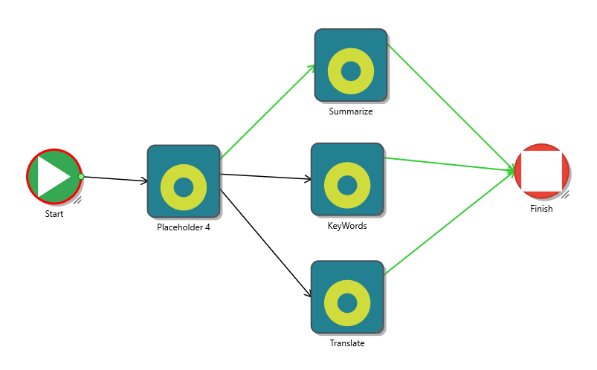

Nota:ThenodeEndin this design it is a bit conceptual. Since it has multiple inputs, it will be executed as soon as the first branch arrives (soJoinModedefaultjmAny). The true power of this pattern will be revealed in the next module when we introduce a join node (Join) before the end.

Step 2: Implementing Parallel Logic
To demonstrate that the nodes are running in parallel, we will introduce an artificial delay (Sleep) in each one. If the flow were sequential, the total time would be the sum of all delays. In a parallel flow, the total time will be approximately that of the longest delay.
- Logic ofnodeStart:Simply pass the topic tolinkFanOut.

procedure TForm1.nodeStartExecute(Node, BeforeNode: TAIAgentsNode;
Link: TAIAgentsLink; Input: String; var Output: String);
begin
Node.Print('Starting topic processing: ' + Input);
Output := Input;
end;

- Worker Node Logic:
Each node will perform its "task", simulate work with aSleepand will save your result to the Blackboard.

procedure TForm1.nodeSummarizeExecute(Node, BeforeNode: TAIAgentsNode;
Link: TAIAgentsLink; Input: String; var Output: String);
begin
Node.Print('>> [Hilo ' + TThread.Current.ThreadID.ToString + '] Iniciando resumen...');
Sleep(2000); // Simulates 2 seconds of work
Output := 'This is a summary about ' + Input + '.';
Node.Graph.Blackboard.SetString('summary_result', Output);
Node.Print('<< [Hilo ' + TThread.Current.ThreadID.ToString + '] Resumen finalizado.');
end;

procedure TForm1.nodeKeywordsExecute(Node, BeforeNode: TAIAgentsNode;
Link: TAIAgentsLink; Input: String; var Output: String);
begin
Node.Print('>> [Hilo ' + TThread.Current.ThreadID.ToString+ '] Starting keyword extraction...');
Sleep(3000); // Simulates 3 seconds of work
Output := 'IA, Delphi, Paralelo';
Node.Graph.Blackboard.SetString('keywords_result', Output);
Node.Print('<< [Hilo ' + TThread.Current.ThreadID.ToString + '] Palabras clave finalizadas.');
end;

procedure TForm1.nodeTranslateExecute(Node, BeforeNode: TAIAgentsNode;
Link: TAIAgentsLink; Input: String; var Output: String);
begin
Node.Print('>> [Hilo ' + TThread.Current.ThreadID.ToString+ '] Starting translation...');
Sleep(1500); // Simulates 1.5 seconds of work
Output := 'This is a text about ' + Input + '.';
Node.Graph.Blackboard.SetString('translate_result', Output);
Node.Print('<< [Hilo ' + TThread.Current.ThreadID.ToString+ '] Translation finished.');
end;

  - We have added theThreadIDto the log. If the parallelism works, you should see differentIDsfor each node (or at least, not always the same as the main thread).

Paso 3: ¡A Probarlo!

Use the same UI and eventsOnPrint, OnEndandOnClickof the button of the previous modules.
- Write in theTEdit: "AI and Delphi."
- Click "Run" and look closely at thememoLog.
Log Esperado:
You'll most likely see the "Starting..." messages appear almost all at once. Then, the "finished" messages will appear in the order in which you finish yourSleep, not in the order in which they are defined (Translation -> Summary -> Keywords).

[TAIAgentsNode] Starting topic processing: AI and Delphi
[TAIAgentsNode] >> [Hilo 1234] Iniciando resumen...
[TAIAgentsNode] >> [Thread 5678] Starting keyword extraction...
[TAIAgentsNode] >> [Thread 9012] Starting translation...
//...1.5 seconds later...
[TAIAgentsNode] << [Thread 9012] Translation finished.
// ...0.5 seconds later (2s total)...
[TAIAgentsNode] << [Hilo 1234] Resumen finalizado.
//...1 second later (3s total)...
[TAIAgentsNode] << [Hilo 5678] Palabras clave finalizadas.

Observaciones Clave:
- Execution Time:The total execution time of the graph will be approximately 3 seconds (the duration of the longest task), not 6.5 seconds (2 + 3 + 1.5). This demonstrates the efficiency gained.
- IDsof Thread:You will notice that theIDsof the threads are different, confirming thatTAIAgentshas used the thread poolTTaskto run the branches in parallel.
- OnEnd:The eventOnEndwill fire as soon as the first branch (translation) reaches thenodeEnd. The main graph, however, will internally wait for all launched tasks to finish before being considered completely finished.

You have successfully implemented a Fan pattern.out, an essential technique for optimizing AI workflows that involve multiple independent tasks.

Module 6: Putting the Pieces Together - Branch Synchronization (Join)
This module is the natural counterpart of the previous one. After we have split our flow into multiple parallel branches (Fan-out), now we will learn to synchronize them at a single junction point (Join). This allows us to ensure that all parallel tasks have finished before proceeding to the next step, such as compiling a final report.
Objetivo:
We will modify the graph from Module 5. Instead of each branch going directly to the end node, we will have them converge at a new "union node". This node will be configured to wait for all three tasks (summary, keywords, translation) to finish. Once all have been completed, it will be run to compile a final report from the results stored on the Blackboard.
Concepto Clave: JoinMode = jmAll
The magic of timing lies in ownershipJoinModeof theTAIAgentsNode.
- jmAny(default): The node runs as soon as the first input signal arrives.
- jmAll: The node counts how many input routes it has. It then waits patiently until it has received a signal from each of those routes before executing just once.
Components that we will use:
- We will reuse most of the graph from Module 5, but with an additional node and are-cableado.
- 1 x TAIAgents
- 6 x TAIAgentsNode
- 5 x TAIAgentsLink(we need fewer links because we no longer go straight to the end from each branch)

Step 1: Redesigning the Graph for the Union
- Add the Union Node:
  - Starting from the design of Module 5, add a newTAIAgentsNode al formulario.
  - Rename it tonodeReport.
- Set theJoinMode:
  - Selecciona nodeReport.
  - In the Object Inspector, look for the propertyJoinModeand change itjmAny a jmAll. This is the most important step!
- Re-cableadoof the Graph:
  - We are going to redirect the output of the three worker nodes (nodeSummarize, nodeKeywords, nodeTranslate) to point to the newnodeReport.
  - Desconecta ofnodeEnd: Elimina the enlaces linkSummarizeToEnd, linkKeywordsToEnd, and linkTranslateToEnd. Or, easier, just change its properties.
  - Create new links tonodeReport:
    - Create a linklinkSummarizeToReport.
      - nodeSummarize.Next -> linkSummarizeToReport
      - linkSummarizeToReport.NextA -> nodeReport
    - Create a linklinkKeywordsToReport.
      - nodeKeywords.Next -> linkKeywordsToReport
      - linkKeywordsToReport.NextA -> nodeReport
    - Create a linklinkTranslateToReport.
      - nodeTranslate.Next -> linkTranslateToReport
      - linkTranslateToReport.NextA -> nodeReport
  - Connect the Join Node to the End:
    - Create a linklinkReportToEnd.
    - nodeReport.Next -> linkReportToEnd
    - linkReportToEnd.NextA -> nodeEnd
The new flow will look like this:

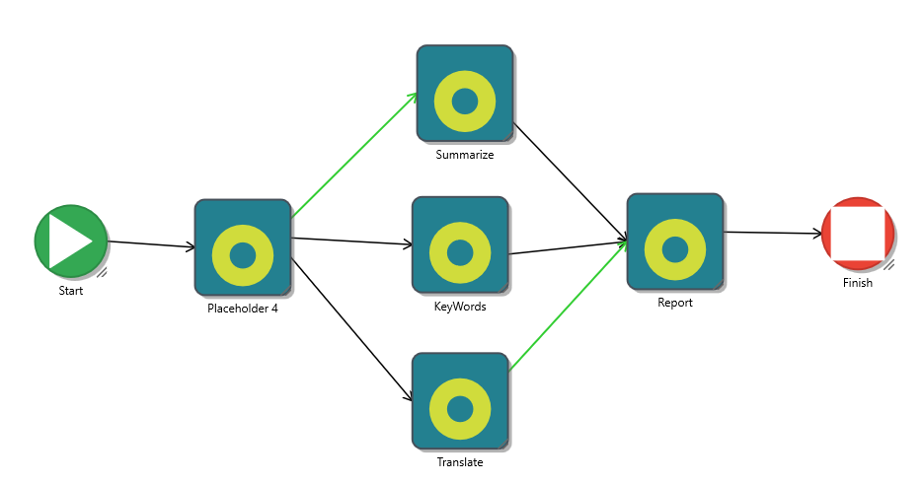

Step 2: Implementing Join Logic
The logic of the worker nodes (nodeSummarize, etc.) from the previous module is already perfect, since they save their results in the Blackboard. Now we just need to implement the logic of thenodeReportto read those results and combine them.
- Logic ofnodeReport:
  - Selecciona nodeReportand double click on your eventOnExecute.
  - Write the following code:

procedure TForm1.nodeReportExecute(Node, BeforeNode: TAIAgentsNode;
Link: TAIAgentsLink; Input: String; var Output: String);
var
ReportBuilder: TStringBuilder;
Summary, Keywords, Translation: string;
begin
Node.Print('>>> All branches have finished! Compiling the final report...');

// We read the results that the previous nodes left on the Blackboard.
Summary := Node.Graph.Blackboard.GetString('summary_result', '[Summary not available]');
Keywords := Node.Graph.Blackboard.GetString('keywords_result', '[Keywords not available]');
Translation := Node.Graph.Blackboard.GetString('translate_result', '[Translation not available]');

// We build the final report.
ReportBuilder := TStringBuilder.Create;
try
ReportBuilder.AppendLine('--- INFORME COMPLETO ---');
ReportBuilder.AppendLine('');
ReportBuilder.AppendLine('Resumen:');
ReportBuilder.AppendLine(Summary);
ReportBuilder.AppendLine('');
ReportBuilder.AppendLine('Palabras Clave:');
ReportBuilder.AppendLine(Keywords);
ReportBuilder.AppendLine('');
ReportBuilder.AppendLine('Translation (English):');
ReportBuilder.AppendLine(Translation);
ReportBuilder.AppendLine('------------------------');

// We assign the complete report as the final output of the graph.
Output := ReportBuilder.ToString;
finally
ReportBuilder.Free;
end;

Node.Print('<<< Informe final compilado.');
end;

Paso 3: ¡A Probarlo!
Uses the same UI and settings as in the previous module. You don't need to change anything else.
- Write in theTEdit: "AI and Delphi."
- Click "Run."
Log and Expected Behavior:
- You will see the "Starting..." messages from all three worker nodes appear almost simultaneously, just as before.
- You will see each worker's "completed" messages appear as they complete their tasks.Sleeps(at 1.5s, 2s and 3s).
- The key difference:Just after the last worker (nodeKeywords) finishes its execution (after 3 seconds), you will see the logs of thenodeReport:
...
[TAIAgentsNode] << [Hilo 5678] Palabras clave finalizadas.
[TAIAgentsNode] >>> All branches are finished! Compiling the final report...
[TAIAgentsNode] <<< Informe final compilado.

- TheShowMessageof the eventOnEndwill now display the complete, well-formatted report that was generated by thenodeReport, rather than a single branch result.

Success!You have implemented a complete Fan pattern.out/Join. You have created a graph that:
- Divide work into parallel tasks for maximum efficiency.
- Safely wait for all tasks to finish.
- Consolidates results from all branches into a unified final output.
This pattern is critical for AI applications that need to collect and process information from multiple sources before presenting a final response to the user.

Module 7: Creating Autonomous Agents with Tools
Until now, all of our business logic has been inside eventsOnExecuteof the nodes. This works for simple examples, but in real applications, it leads to duplicate code and a mix of responsibilities (orchestration logic mixed with business logic).
The componentTAiToolBasesolve this problem. It allows us to encapsulate a specific capability—such as querying a database, calling a web API, or reading a file—in a reusable component. Then a node can simplyusarthat tool instead of implementing the logic itself.
Objetivo:
Let's build a simple agent that can perform a "real world" task: query the weather.
- We will create a new classTWeatherToolthat inherits fromTAiToolBase.
- This tool will simulate a call to a weather API.
- We will create a simple graph where a node, instead of using its eventOnExecute, you will use theTWeatherToolto obtain the information.

Paso 1: Creando Nuestra Primera Herramienta (TWeatherTool)
A tool is simply a Delphi class. We can add it to a new unit in our project to keep the code organized.
- Add a new drive to your project (File -> New ->Unit). Save it asuMyTools.pas.
- In this new unit, write the code for our weather tool.

// uMyTools.pas
unit uMyTools;

interface

uses
System.SysUtils, System.Classes, uMakerAi.Agents; // Make sure to adduMakerAi.Agents

type
TWeatherTool = class(TAiToolBase)
protected
// This is the method we must implement
procedure Execute(ANode: TAIAgentsNode; const AInput: string; var AOutput: string); override;
public
constructor Create(AOwner: TComponent); override;
end;

implementation

{ TWeatherTool }

constructor TWeatherTool.Create(AOwner: TComponent);
begin
inherited;
// It's good practice to set the description here.
// This description is key so that LLMs can understand what the tool does.
Self.Description := 'Gets the weather forecast for a specific city. The entry must be the name of the city.';
end;

procedure TWeatherTool.Execute(ANode: TAIAgentsNode; const AInput: string; var AOutput: string);
var
City: string;
begin
City := AInput;
ANode.Print(Format('TWeatherTool: Querying time for city "%s"...', [City]));

// --- Simulation of a weather API call ---
// In a real case, your code would go here withTRESTClient, etc.
// For this example, we only return fixed city-based data.
Sleep(1500); // Simulate network latency

if City.ToLower.Contains('madrid') then
AOutput := 'The weather in Madrid is sunny, 25°C.'
else if City.ToLower.Contains('londres') then
AOutput := 'The weather in London is cloudy, 15°C.'
else if City.ToLower.Contains('berlin') then
AOutput := 'The weather in Berlin is rainy, 12°C.'
else
AOutput := Format('Could not find time for city "%s".', [City]);

ANode.Print('TWeatherTool: Consulta finalizada.');
end;

end.

Importante:Go back to your main form unit and adduMyToolsto the uses clause of the sectionimplementation.

Step 2: Building the Graph that the Tool Will Use
Now we will design a very simple graph that uses our new tool.
- Components in the Form:
  - AgentManager (TAIAgents)
  - nodeStart (TAIAgentsNode)
  - nodeGetWeather (TAIAgentsNode)
  - nodeEnd (TAIAgentsNode)
  - linkStartToWeather (TAIAgentsLink)
  - linkWeatherToEnd (TAIAgentsLink)
- Add the Tool to the Form:
  - To use ourTWeatherTool, we need an instance of it. We can create it dynamically. At the eventOnCreateof the form, add:

// In the ' sectionprivate' from your form declaration
private
FWeatherTool: TWeatherTool;

// At the eventOnCreateof the form
procedure TForm1.FormCreate(Sender: TObject);
begin
FWeatherTool := TWeatherTool.Create(Self); // We create the tool
// ... (other initialization code can go here)
end;

// Don't forget to release it in theOnDestroy
procedure TForm1.FormDestroy(Sender: TObject);
begin
FWeatherTool.Free;
inherited;
end;

(Expert alternative: You could useRegisterComponentsso that your tool appears in the palette and you can drag and drop it like any other component. For this manual, creating by code is more direct.)
- Graph Wiring:
AgentManager.StartNode -> nodeStart
AgentManager.EndNode -> nodeEnd
nodeStart.Next -> linkStartToWeather
linkStartToWeather.NextA -> nodeGetWeather
nodeGetWeather.Next -> linkWeatherToEnd
linkWeatherToEnd.NextA -> nodeEnd
- Assign the Tool to the Node:
  - Selecciona nodeGetWeather.
  - Go to the Item Inspector. Find the Tool property.
  - This is the key step!Instead of using the dropdown, let's assign it by code to make it explicit. In theFormCreate, after creating the tool, add:

nodeGetWeather.Tool := FWeatherTool;

Step 3: Implementing the Logic (Minimal)
The beauty of this approach is that we hardly need to write logic in the form's events.
- Logic ofnodeStart:
This node only passes the input (the city name).

procedure TForm1.nodeStartExecute(Node, BeforeNode: TAIAgentsNode;
Link: TAIAgentsLink; Input: String; var Output: String);
begin
Output := Input;
end;

- Logic ofnodeGetWeather:
  - Don't implement the eventOnExecute!
  - The node, upon running, will see that it has a Tool assigned to it. Will ignore your (non-existent)OnExecuteand will instead call the methodExecuteof ourTWeatherTool. The Input of the node will be automatically passed to theAInputof the tool, and theAOutputof the tool will become the Output of the node.

Paso 4: ¡A Probarlo!
- Use the same UI as the previous modules.
- Run the application.
- Write in theTEdit: "I want to know the weather in Madrid."
- Click "Run."
Log and Expected Result:
- Log:
[TAIAgentsNode] TWeatherTool: Consulting weather for the city "I want to know the weather in Madrid"...
[TAIAgentsNode] TWeatherTool: Consulta finalizada.

- Mensaje Final:"The graph has finished. Final result: The weather in Madrid is sunny, 25°C."

Analysis of Success!
You have successfully separated business logic from orchestration.
- Your graph (TForm) now only cares about theflujo: Start -> GetWeather -> End.
- The complex logic ofhowget time is encapsulated inTWeatherTool.
Ahora puedes reutilizar TWeatherToolin any other graph. If the weather API changes tomorrow, just modify the unituMyTools.pas, and all your graphs that use it will be updated automatically without having to touch the form logic.
This pattern is the basis for building complex agents. Imagine having a set of tools:TDatabaseTool, TEmailTool, TCalendarTool. You can build graphs that combine these tools to automate sophisticated tasks, all while keeping your code clean, modular, and scalable.

Module 8: Error and Cycle Management
A robust AI system is not one that never fails, but one that can anticipate, handle, and recover from failures elegantly.MakerAI Agentsprovides several mechanisms to handle errors and control repetitive flows (cycles) to prevent them from going out of control.
Objetivo:
We will build a graph that attempts to perform a "critical action" that may fail.
- If the action is successful, the graph ends.
- If the action fails, the flow will be redirected to an "error handling" node that will log the problem.
- We will implement a controlled retry mechanism (loop) that will try the action a maximum number of times before giving up.
Conceptos Clave:
- TAIAgents.OnError:The global event to catch unhandled exceptions.
- TAIAgentsLink.OnExecute:The event of a link where we can introduce logic to determine if a transition is successful (IsOk := True) or failed (IsOk := False).
- TAIAgentsLink.NextNo:The path the flow takes when a transition fails (IsOkis False).
- TAIAgentsLink.MaxCicles:The guardian against infinite loops.

Step 1: Design of the Robust Graph
- Components in the Form:
  - AgentManager (TAIAgents)
  - nodeStart (TAIAgentsNode)
  - nodeAttemptAction (TAIAgentsNode): The node that will attempt the critical action.
  - nodeErrorHandler (TAIAgentsNode): The node we will go to if the action fails.
  - nodeSuccess (TAIAgentsNode): The final node if everything goes well.
- Graph Wiring (with a Cycle):
  - AgentManager.StartNode -> nodeStart
  - AgentManager.EndNode -> nodeSuccess(Be careful! The happy ending isnodeSuccess).
  - OfnodeStartto action:
    - Crea linkStartToAction.
    - nodeStart.Next -> linkStartToAction
    - linkStartToAction.NextA -> nodeAttemptAction
  - The critical link (linkAction):This is the heart of our design.
    - Crea linkAction.
    - nodeAttemptAction.Next -> linkAction
    - Success Route: linkAction.NextA -> nodeSuccess.
    - Failure Path: linkAction.NextNo -> nodeErrorHandler.
    - Cycle Control: Selecciona linkActionand in the Object Inspector, setMaxCiclesto 3. This means we will allow 3 attempts.
  - The Retry Cycle:
    - To retry, we need a link that goes from our error handler back to the action node.
    - Crea linkRetry.
    - nodeErrorHandler.Next -> linkRetry
    - linkRetry.NextA -> nodeAttemptAction.
The flow will look like this:

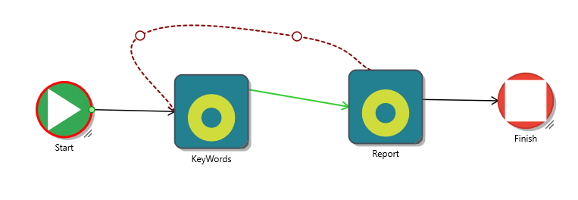

Step 2: Implementing Failure and Retry Logic
- Simulating a failure:To test this, we need a way to make our "critical action" fail from time to time. We will use a simple counter in our form.
  - Add a private variable to your TForm:FAttemptCounter: Integer;
  - In theOnClickof the buttonbtnRun, reset the counter:FAttemptCounter := 0;
- Logic ofnodeAttemptAction:
This node simply records that it is attempting the action.

procedure TForm1.nodeAttemptActionExecute(Node, BeforeNode: TAIAgentsNode;
Link: TAIAgentsLink; Input: String; var Output: String);
begin
Inc(FAttemptCounter);
Node.Print(Format('Attempt #%d: Performing critical action...', [FAttemptCounter]));
// The result of this node is not important, the decision is made at the link.
Output := 'Action attempted';
end;
- Critical Link Logic (linkAction.OnExecute):
This is where we decide if the attempt was successful or not.

procedure TForm1.linkActionExecute(Node: TAIAgentsNode; Link: TAIAgentsLink;
var IsOk: Boolean; var Handled: Boolean);
begin
// We simulate that the action only succeeds on the third attempt.
if FAttemptCounter >= 3 then
begin
Node.Print('SUCCESS! The critical action worked.');
IsOk :=True; // The flow will continue forNextA hacia nodeSuccess!
end
else
begin
Node.Print('FAILED. The critical action did not work this time.');
IsOk :=False; // The flow will be diverted byNextNo hacia nodeErrorHandler!
end;
end;

- Logic ofnodeErrorHandler:
This node is executed whenIsOkis False. Your job is to log the error and then pass control to the retry link.

procedure TForm1.nodeErrorHandlerExecute(Node, BeforeNode: TAIAgentsNode;
Link: TAIAgentsLink; Input: String; var Output: String);
begin
Node.Print('Error Handler: Action failed. Preparing retry...');
Sleep(1000); // Wait one second before retrying.
end;

- Logic ofnodeSuccess:
This is our happy ending.

procedure TForm1.nodeSuccessExecute(Node, BeforeNode: TAIAgentsNode;
Link: TAIAgentsLink; Input: String; var Output: String);
begin
Output := Format('Process completed successfully at attempt #%d.', [FAttemptCounter]);
end;

Paso 3: Manejando Excepciones Fatales (OnError)
What happens if an error occurs that we don't control, such as division by zero or a null object? O, what pasa yes excedemos MaxCicles? For eso is the evento OnError of the AgentManager.
- Selecciona AgentManagerand double click on your eventOnError.

procedure TForm1.AgentManagerError(Sender: TObject; Node: TAIAgentsNode;
Link: TAIAgentsLink; E: Exception; var Abort: Boolean);
begin
var ErrorMsg := '¡ERROR FATAL! ' + E.Message;
if Assigned(Node) then
ErrorMsg := ErrorMsg+ ' in Node: ' +Node.Name
else if Assigned(Link) then
ErrorMsg := ErrorMsg+ ' in Link: ' +Link.Name;

TThread.Synchronize(nil, procedure
begin
memoLog.Lines.Add(ErrorMsg);
ShowMessage('The graph has failed irrecoverably.');
btnRun.Enabled := True;
end);

Abort :=True; // We tell the agent to stop all execution.
end;

Paso 4: ¡A Probarlo!
- Run the application. You don't need to write anything in itTEdit.
- Click "Run."

Log Esperado:
You will see the cycle in action. The graph will try, fail, go to the error handler, retry, and so on, until it finally succeeds.

[TAIAgentsNode] Attempt #1: Performing critical action...
[TAIAgentsNode] FAILED. The critical action didn't work this time.
[TAIAgentsNode] Error Handler: The action failed. Preparing retry...
[TAIAgentsNode] Attempt #2: Performing critical action...
[TAIAgentsNode] FAILED. The critical action didn't work this time.
[TAIAgentsNode] Error Handler: The action failed. Preparing retry...
[TAIAgentsNode] Attempt #3: Performing critical action...
[TAIAgentsNode] SUCCESS! The critical action worked.
Mensaje Final:"The network has ended. Final result: Process completed successfully on attempt #3."

Test ofMaxCicles:
If you modify the logic oflinkActionExecuteso thatsiempre falle (IsOk := False;), when you execute you will see two retries. On the third failure, instead of continuing, the linklinkActionwill detect that it has been reachedMaxCicles. It will throw an internal exception that will be caught by your eventAgentManager.OnError, and you will see the fatal error message.
You have learned to build graphs that not only execute tasks, but are also resilient to failures, capable of retrying, and handling unexpected errors in a controlled manner.

Appendix A: API Reference
This appendix serves as a technical reference guide for the main components, properties, methods and events of the framework.MakerAI Agents.

A.1 TAIAgents (El Orquestador)
Primary component that manages the execution and state of an AI graph.
Propiedades Publicadas:
- StartNode: TAIAgentsNode: (Requerido)The first node to run when calling Run.
- EndNode: TAIAgentsNode: (Requerido)The node that, when reached, marks a nominal completion of the graph. YourOnExecutedoes not run automatically, but the eventOnEndof the orchestrator does trigger.
- OnPrint: TAIAgentsOnPrint: Event forlogging. Triggered when any node or link calls its methodPrint.
- OnEnd: TAIAgentsOnEnd: Event that is triggered when the graph completes its execution. Receives the last executed node and its Output.
- OnError: TAIAgentsOnError: Global event to handle unhandled exceptions within the graph execution.
- OnConfirm: TAIAgentsOnConfirm: Event to facilitate interaction with the UI. Allows you to pause the network and request confirmation or user data.
Read Only Properties:
- Busy: Boolean: Returns True if the graph is currently running.
- Blackboard: TAIBlackboard: Provides access to the shared whiteboard instance for this graph run.
Public Methods:
- Run(Msg: String): ITask: Starts the execution of the graph asynchronously.
  - Msg:Thestringinitial that will be passed as Input to theStartNode.
  - Devuelve:oneITaskwhich represents background execution. You can useTTask.WaitForAllif you need to wait for it to finish.
- Abort: Requests the stop of the running network. The stopping is not immediate, but the nodes and links will stop running at the next checkpoint.
- Compile: Analyzes the structure of the graph, validates connections and prepares internal dependencies. Automatically called within Run if the graph has not been compiled.
- FindNode(const AName: string): TAIAgentsNode: Searches for and returns a node by name. Useful for building graphs by code.
- ClearGraph: Removes all dynamically created nodes and links.

A.2 TAIAgentsNode (El Nodo)
Represents a unit of work or a step in the graph.
Propiedades Publicadas:
- Next: TAIAgentsLink: The output link that will be executed after this node.
- Input: String: The input data for the node. It is usually filled with the Output of the previous node.
- Output: String: The result of the node's work. It will be passed as Input to the next one.
- OnExecute: TAIAgentsNodeOnExecute: The main event where the node logic is defined.Takes precedence over the Tool property.
- Tool: TAiToolBase: Assigns a reusable tool component to execute the node logic. Only used ifOnExecuteis not assigned.
- JoinMode: TJoinMode: (jmAny, jmAll) Defines the behavior of the node when it has multiple input links.jmAllcauses the node to wait for all branches to arrive before executing.
- PromptName: String: General purpose property to associate a name (for example, from a prompt) to the node. It has no internal functionality.
Public Methods:
- Print(Value: String): Send a log message to the eventOnPrintof the orchestrator.
- RequestConfirmation(...): Requests user interaction through the eventOnConfirmof the orchestrator.
- RequestInput(...): An assistant onRequestConfirmationto prompt the user for a text value.
- ForceFinalExecute: Forces the execution of the eventOnEndof the orchestrator, using this node as the finalizer. Useful for abrupt endings.

A.3 TAIAgentsLink (El Enlace)
Defines the flow and transition logic between nodes.
Propiedades Publicadas:
- NextA: TAIAgentsNode: The main destination or the first destination in a parallel run (Fan-out).
- NextB, NextC, NextD: TAIAgentsNode: Additional targets for parallel execution.
- NextNo: TAIAgentsNode: The destination that will be taken if the link logic determines a failure (e.g.IsOk := False inOnExecuteor is surpassedMaxCicles).
- MaxCicles: Integer(Default: 1): The maximum number of times the flow can pass through this link in one cycle before throwing a "maximum cycles reached" error. A value of 1 effectively disables loops through this link.
- OnExecute: TAIAgentsLinkOnExecute: Event to implement custom transition logic. Allows you to decide if the transition is valid (IsOk) or whether the flow should be stopped (Handled).
Public Methods:
- AddConditionalTarget(const AKey: string; ANode: TAIAgentsNode): Adds a route to the conditional routing dictionary. The link will take this path if the key value 'next_route' on Blackboard matchesAKey.
- Print(Value: String): Send a log message to the eventOnPrintof the orchestrator.

A.4 TAIBlackboard (La Pizarra)
Access class to the shared state of the graph. Accessible throughTAIAgents.Blackboard.
Main Public Methods:
- SetString(const AKey, AValue: string)
- GetString(const AKey: string; const ADefault: string = ''): string
- SetInteger(const AKey: string; AValue: Integer)
- GetInteger(const AKey: string; const ADefault: Integer = 0): Integer
- SetBoolean(const AKey: string; AValue: Boolean)
- GetBoolean(const AKey: string; const ADefault: Boolean = False): Boolean
- SetValue(const AKey: string; const AValue: TValue): The generic method to save any type supported byTValue.
- TryGetValue(const AKey: string; out AValue: TValue): Boolean: The generic method to safely read any type.
- Clear: Empties all Blackboard content. Called automatically at the start of Run.

Appendix B: Creating Custom Tools (TAiToolBase)
While the eventOnExecuteof a node is perfect for unique, form-specific logic, the real powerof modularityand reuse is unlocked by creatingHerramientaspersonalized. A well-designed tool encapsulates a business or technical functionality, hiding its internal complexity and providing a simple interface to the graph.
This appendix covers best practices and advanced techniques for building your own tools.

B.1 The Fundamental Structure of a Tool
As we saw in Module 7, the basic structure of a tool is incredibly simple. Inherits fromTAiToolBaseand implement the methodExecute.

unit uMyDataAccessTools;

interface

uses
System.SysUtils, System.Classes, Data.DB, uMakerAi.Agents;

type
TDatabaseQueryTool = class(TAiToolBase)
private
FConnection: TFDConnection; // Example withFireDAC
FQuery: TFDQuery;
protected
procedure Execute(ANode: TAIAgentsNode; const AInput: string; var AOutput: string); override;
public
constructor Create(AOwner: TComponent); override;
destructor Destroy; override;
published
// Properties to configure the tool in the Object Inspector
property Connection: TFDConnection read FConnection write FConnection;
end;

implementation
//...implementation...
end;

Best Practices in Design:
- Single Responsibility Principle (SRP):A tool must doone thing, and do it well.
  - Mal: TDoEverythingToolwhich queries the DB, calls an API and writes a file.
  - Bien: Tres herramientas separadas: TDatabaseQueryTool, TWebApiGetTool, TFileWriterTool. This makes them easier to test, debug and compose in different graphs.
- Configuration through Properties:Expose any configuration parameters (such as connection objects,URLsof APIs, file names, etc.) as propertiespublished. This allows you to easily configure the tool from the Delphi Object Inspector if you register it as a component.
- Description is Key:The propertyDescriptionIt is vital. It is not a simple comment. It is thesemanticsof the tool. Write a clear and concise description that explains:
  - What the tool does.
  - What exactly do you expect as Input.
  - What it returns as Output.
  - Ejemplo:`"Executes a read-only SQL query (SELECT). The Input must be the entire SQL statement. Returns the result of the first column of the first row, or an empty string if there are no results."*

B.2 Interacting with the Graph from a Tool
The methodExecute recibe ANode: TAIAgentsNodeas a parameter. This object is your gateway to interact with the rest of the graph.
- Logging: Usa ANode.Print('...') to send messages to the orchestrator log. This is crucial for thedepurabilidad. Don't useShowMessageorWritelninside a tool as it runs in a secondary thread and has no access to the console or UI.
- Acceso al Blackboard:You can read and write on Blackboard throughANode.Graph.Blackboard. This is extremely useful for a tool to return complex data or multiple values.
Advanced Example: Tool that returns multiple values

procedure TUserInfoTool.Execute(ANode: TAIAgentsNode; const AInput: string; var AOutput: string);
var
UserID: Integer;
UserName, UserEmail: string;
begin
try
UserID := StrToInt(AInput);
except
AOutput := 'Error: The input must be a numeric user ID.';
Exit;
end;

ANode.Print(Format('Searching for information for user ID: %d', [UserID]));

// --- Logic to search the user in the database ---
// (Simulated for example)
FindUserInDB(UserID, UserName, UserEmail);

// We write the complex data to Blackboard for other nodes to use.
ANode.Graph.Blackboard.SetString('current_user_name', UserName);
ANode.Graph.Blackboard.SetString('current_user_email', UserEmail);

// The main Output can be a simple summary or a state.
AOutput := Format('User information %s successfully uploaded.', [UserName]);
end;
In this example, the tool does its job and then "enriches" the state of the graph (the Blackboard) with detailed information that can be used by later nodes in the flow.

B.3 Registering your Tools as Components
For seamless integration with the Delphi IDE, you can register your tools to appear in the Components Palette. This allows you to drag them to your form orDataModule, configure them visually and assign them to the nodes through the Object Inspector drop-down menu.
- Create a unit of record (for example,uMyToolsRegister.pas).
- Add the following code:

unit uMyToolsRegister;

interface

procedure Register;

implementation

uses System.Classes, uMyDataAccessTools, uMyApiTools; // Units where your tools are

procedure Register;
begin
// Register your tools in a tab of the Component Palette.
// You can use an existing tab or create a new one.
RegisterComponents('MakerAI Tools', [TDatabaseQueryTool, TWebApiGetTool]);
end;

end.

Add this record unit to your design package (.dpk) or install it in the IDE. Once done, your tools will be available like any other visual or non-visual component.

Appendix C: Dynamic Graph Construction (Fluent API)
While the Delphi form designer is a fantastic tool for defining static graphs, there are scenarios where you need to build, modify, or run a graph entirely by code.MakerAI Agentsexposes a fluent API (fluentAPI) that allows you to chain method calls to define the structure of a graph in a readable and concise way.
This is ideal for:
- Create workflows based on business rules loaded from a database.
- Dynamically generate graphs in response to user input.
- Integrate orchestration into systems where there is no visual user interface (such as Windows services or web servers).
- Perform unit tests of the graph logic.

C.1 The Building Blocks of the Fluent API
The componentTAIAgentshas a series of methods that, when returningSelf, allow you to chain the next call.
- AddNode(const AName: string; AExecuteProc: TAIAgentsNodeOnExecute): TAIAgents;
  - Create a newTAIAgentsNodeand adds it to the graph.
  - AName: A unique name for the node. It is crucial as you will use it to reference it when creating the links.
  - AExecuteProc: A pointer to the anonymous procedure or method that will implement the logicOnExecuteof the node.
- AddEdge(const AStartNodeName, AEndNodeName: string): TAIAgents;
  - Create aTAIAgentsLinksimple that connects two nodes by their names.
- AddConditionalEdge(const AStartNodeName: string; const AConditionalLinkName: string; AConditionalTargets: TDictionary<string, string>): TAIAgents;
  - Create a conditional link.
  - AStartNodeName: The source node.
  - AConditionalLinkName: A name for the new link.
  - AConditionalTargets: A dictionary where the key is the decision value (to be read from Blackboard['next_route']) and the value is the name of the destination node.
- SetEntryPoint(const ANodeName: string): TAIAgents;
  - Defines which of the created nodes will be theStartNodeof the graph.
- SetFinishPoint(const ANodeName: string): TAIAgents;
  - Define what will be theEndNode.

C.2 Practical Example: Recreating the Conditional Graph by Code
We are going to recreate the sentiment analysis graph from Module 4, but this time without using any design-time components except aTAIAgents (AgentManager), aTButtonand aTMemo.

procedure TForm1.btnRunDynamicGraphClick(Sender: TObject);
begin
memoLog.Clear;

// 1. Limpiamos cualquier grafo definido previamente
AgentManager.ClearGraph;

// 2. We define the logic of our nodes usingmÃ©todos anÃ³nimos
var AnalyzeLogic: TAIAgentsNodeOnExecute :=
procedure(Node, BeforeNode: TAIAgentsNode; Link: TAIAgentsLink; Input: String; var Output: String)
var
Decision: string;
begin
if Pos('bien', Input.ToLower) > 0 then Decision := 'positivo'
else if Pos('mal', Input.ToLower) > 0 then Decision := 'negativo'
else Decision := 'neutro';
Node.Print('NodeAnÃ¡lisis (dinÃ¡mico): DecisiÃ³n -> ' + Decision);
Node.Graph.Blackboard.SetString('next_route', Decision);
Output := Input;
end;

var PositiveLogic: TAIAgentsNodeOnExecute :=
procedure(Node, BeforeNode: TAIAgentsNode; Link: TAIAgentsLink; Input: String; var Output: String)
begin
Output := 'Respuesta positiva generada dinÃ¡micamente.';
end;

var NegativeLogic: TAIAgentsNodeOnExecute :=
procedure(Node, BeforeNode: TAIAgentsNode; Link: TAIAgentsLink; Input: String; var Output: String)
begin
Output := 'Respuesta negativa generada dinÃ¡micamente.';
end;

// 3. We build the graph using the fluid API
AgentManager.AddNode('Start', nil) // A simple startup node without logic
.AddNode('Analyze', AnalyzeLogic)
.AddNode('PositiveResponse', PositiveLogic)
.AddNode('NegativeResponse', NegativeLogic)
.AddNode('End', nil) // A simple end node
.AddEdge('Start', 'Analyze') // We connect the start with theanÃ¡lisis
.AddConditionalEdge('Analyze', 'RouterLink',
TDictionary<string, string>.Create
.Add('positivo', 'PositiveResponse')
.Add('negativo', 'NegativeResponse')
)
.AddEdge('PositiveResponse', 'End') // We connect the branches at the end
.AddEdge('NegativeResponse', 'End')
.SetEntryPoint('Start')
.SetFinishPoint('End');

// Optional: For the neutral route,podrÃ­amosfind the link and assignNextNo.
// (This part is less "fluid" for now)
var RouterLink := TAIAgentsLink(AgentManager.FindComponent('RouterLink'));
if Assigned(RouterLink) then
RouterLink.NextNo := AgentManager.FindNode('End');

// 4. We compile and execute the graphreciÃ©n creado
AgentManager.Compile;
AgentManager.Run('the service was very good');
end;

Code Analysis:
- Decoupled Logic:We define the functionality of each node as variables of typeTAIAgentsNodeOnExecute. This keeps the logic separate from the structure. They could be methods of a class instead of anonymous procedures for better organization.
- Chained Construction:See how each call(.AddNode, .AddEdge, etc.) is chained to the previous one, making the definition of the graph structure very readable and similar to a "recipe".
- Flexibilidad Total:You could load the node names, their connections, and the logic to be executed from a JSON file, a database, or any other external configuration source, allowing the creation of completely dynamic AI orchestration systems.

This approach is undoubtedly more advanced, but it unlocks the highest level of flexibility and power of the library.MakerAI Agents, allowing you to integrate it into complex and dynamic software architectures.

Glossary of Terms
This section provides concise definitions of key terms and components used throughout the manual.MakerAI Agents.

A
- Agente (Agent)A system or program that uses a Large Language Model (LLM) as its reasoning engine to perceive its environment, make decisions, and execute actions through Tools to achieve a goal.
- API Fluida (Fluent API)A style of programming interface design in which the readability of the source code is close to that of ordinary prose. It is achieved by chaining method calls (objeto.Metodo1().Method2().Method3()). In MakerAIAgents, is used for the construction of graphs by code.
B
- Blackboard (Pizarra)A centralized, shared data repository, specific to a single execution of the graph. It acts as the "short-term memory" of the agent, allowing Nodes and Links to communicate with each other, pass complex data, and maintain state. Corresponds to the componentTAIBlackboard.
E
- Enlace (Link / Edge)The component that connects two or more Nodes, defining the direction of flow. A link can contain logic for conditional routing, parallel execution (Fan-out) and fault handling. Corresponds to the componentTAIAgentsLink.
- Enrutamiento CondicionalThe ability of a Link to direct flow to different destination Nodes based on a condition, typically a value stored in the Blackboard. It is the main mechanism for decision making in a graph.
F
- Fan-out(Parallel Execution)The process of dividing the flow of a graph into multiple branches that execute simultaneously. It is achieved by configuring a single Link with multiple destination Nodes (NextA, NextB, etc.).
G
- Grafo (Graph)The complete structure that defines a workflow, composed of Nodes (the steps) and Links (the connections). Unlike a linear chain, a graph can have branches, cycles and unions, allowing complex processes to be modeled. The network is managed by the componentTAIAgents.
H
- Herramienta (Tool)A reusable component that encapsulates a specific capability to interact with external systems (databases, APIs, files, etc.). The tools promote code reuse and separation of responsibilities. Corresponds to the base classTAiToolBase.
J
- Join(Union/Synchronization)The process of waiting for multiple parallel branches (created by a Fan-out) complete their execution before continuing with a single next step. It is achieved by configuring a Node with the propertyJoinModeinjmAll.
L
- LLM (Large Language Model/Large Language Model)An artificial intelligence model trained with enormous amounts of text, capable of understanding and generating human language. It is the "brain" or reasoning engine that an Agent uses to make decisions. Examples: GPT-4, Gemini, Llama.
N
- Nodo (Node)The fundamental unit of work in a graph. Represents a specific step or action in the workflow, such as processing data, calling an LLM, or running a Tool. Corresponds to the componentTAIAgentsNode.
Or
- Orchestration (Orchestration)The process of coordinating and managing a sequence of complex and distributed tasks. In the context of AI, it refers to managing the flow of calls to LLMs, tools and other logic to solve a problem that goes beyond a simple question and answer. MakerAIAgentsIt is an orchestration framework.
S
- Estado (State)The information accumulated during the execution of a graph. It is managed through theBlackboard and allows the graph to "remember" results, decisions and data as it moves through the different Nodes.

